Task 1 - Analysis on ML Test Scores.

Batch - Represents the Batch Name
User_ID - Represents the unique student id
Score - Represents the Score out of 7

Source code :-
import pandas as pd
import matplotlib.pyplot as plt
df = pd.read_csv("scores_data.csv")
print(df)
Output :-
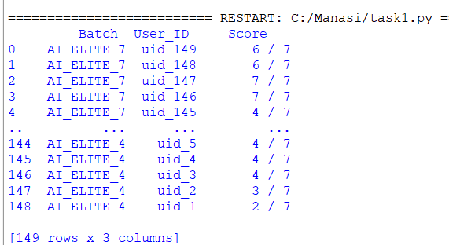

Source code :-
# Clean column names
df.columns = df.columns.str.strip()
print("Columns:", df.columns)

Output :-

Source code :-
# Replace 'Scores' with actual column name if needed
df['Score'] = df.iloc[:, 2].str.split('/').str[0].astype(int)
# Analysis
print("\nStudents per batch:")
print(df['Batch'].value_counts())
Output :-
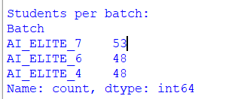

Source code :-
stats = df.groupby('Batch')['Score'].agg(['count', 'mean', 'median', 'min', 'max'])
print("\nBatch-wise statistics:")
print(stats)
Output :-
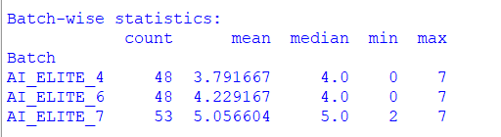

Source code :-
stats['mean'].plot(kind='bar', title='Average Score per Batch')
plt.ylabel("Score out of 7")
plt.show()
Output : -
